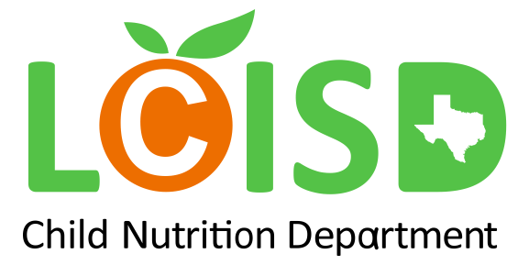

Summer Curbside Meals
USDA has extended waivers that allow Lamar CISD to offer meals at no charge to students through the end of Summer.
FREE curbside meals are available to all LCISD students and children 18 and under who are not enrolled in Lamar CISD. Families will have the option to order a multi-day meal kit consisting of 5 breakfasts and 5 lunches. Families are required to fill-out an online form every Wednesday by 8pm prior to meal pickup. This form can be found on the Lamar CISD Child Nutrition Department Page. Meals will not be provided if the form is not submitted. Parents must provide documentation if a car placard has not been previously received. For students enrolled in Lamar CISD, the following forms of ID are acceptable, student ID issued by the district, a schedule, or any correspondence from the school with the student ID number on it. If the child is not enrolled in Lamar CISD and is not present during meal pick up, parent(s) must present a birth certificate for each child he/she is picking up for.
If you need additional guidance or would like to add your email to the weekly order form, please contact the Child Nutrition Office at 832-223-0180.
Click to Pre-Order for June 7th – June 11th
Dates of Operation: Every Monday from June 7, 2021 – August 16, 2021
The sites below will be open on Mondays from 8:45am- 11:00am for meal pick up through the bus porch area.
- Beasley Elementary: 7511 Avenue J, Beasley, TX 77417
- Fulshear High School: 9302 Charger Way, Fulshear, TX 77441
- George Ranch High School: 8181 FM 762 Rd, Richmond, TX 77469
- Smith Elementary: 2014 Lamar Dr, Richmond, TX 77469
- Taylor Ray Elementary: 2611 Avenue N, Rosenberg, TX 77471
Instructions to successfully and safely pickup meals:
- Submit google form by Wednesday 8pm every week.
- Ensure re-usable car placard is displayed each week up for verification.
- Upon arrival to pre-selected serving site, allow employees access to vehicle where bagged meal kits can be placed inside of vehicle trunks, truck beds and/or backseats.

Stay Healthy, Clean, and Safe
Below are some simple food safety guidelines for your meals.
- Wash your hands before eating these meals.
- Cold meals should be eaten immediately or refrigerated within 2 hours of receiving the meals. Foods like dairy (milk, cheese, etc.) and meats should be quickly refrigerated at a temperature of 41ºF or lower.
  - Red bag contains frozen lunch entrees and side items, place in freezer.
  - Blue bag contains frozen breakfast items, place in the freezer.
  - Yellow bag contains side items, place in the refrigerator.
  - Clear bag contains juice and/or milk, place in the refrigerator.
- Hot meals should be eaten immediately or refrigerated within 2 hours of receiving the meals. Any foods should be reheated at a minimum temperature of 165ºF.
- Any leftovers from this meal should be thrown out after 5 days of receiving it! Throw out any meal that is left out for 4 hours or longer at room temperature.

USDA Nondiscrimination Statement

Non-discrimination Statement: This explains what to do if you believe you have been treated unfairly.

In accordance with Federal civil rights law and U.S. Department of Agriculture (USDA) civil rights regulations and policies, the USDA, its Agencies, offices, and employees, and institutions participating in or administering USDA programs are prohibited from discriminating based on race, color, national origin, sex, disability, age, or reprisal or retaliation for prior civil rights activity in any program or activity conducted or funded by USDA. Persons with disabilities who require alternative means of communication for program information (e.g. Braille, large print, audiotape, American Sign Language, etc.), should contact the Agency (State or local) where they applied for benefits. Individuals who are deaf, hard of hearing or have speech disabilities may contact USDA through the Federal Relay Service at (800) 877-8339. Additionally, program information may be made available in languages other than English.
To file a program complaint of discrimination, complete the USDA Program Discrimination Complaint Form, (AD-3027) found online at: https://www.usda.gov/oascr/how-to-file-a-program-discrimination-complaint,and at any USDA office, or write a letter addressed to USDA and provide in the letter all of the information requested in the form. To request a copy of the complaint form, call (866) 632-9992. Submit your completed form or letter to USDA by: (1) mail: U.S. Department of Agriculture, Office of the Assistant Secretary for Civil Rights, 1400 Independence Avenue, SW, Washington, D.C. 20250-9410; (2) fax: (202) 690-7442; or (3) email: program.intake@usda.gov.
This institution is an equal opportunity provider.

