Obtaining Your Skyward Family Access Username and Password

Go to www.lcisd.org and click on the Family Access tab at the top-left of your screen.
Next, click on the “Other Family Access Issues” on the right-hand side of your screen.
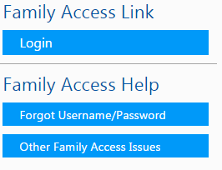
An assistance form will appear. Fill in all the information asked for on the form, and click on “Submit Help Request”.

You will receive an email message to the mailbox of the email address that you entered on the form that is entitled, “Family Access Account Info”.
Open the email.
Click on the first link.
When the new webpage opens, type the letters or numbers that you see into the text box.
Then, type in your email address below the box.
Click “submit”.
A message will pop up; click “OK”.

Soon, you will receive a second email entitled, “Forgotten Login/Password Assistance”.
Open the email.
Click on the first link.
When the new webpage opens you will see your name at the top of a box.
Under your name you will see the word “login” and some information next to it.
This is your Skyward Username. Typically it is your first name.last name (or some variation of that).
Underneath your username (login) you have the opportunity to create your own password. It can be anything that you want it to be. You will be required to type it in twice.
When you have finished entering your password, click “submit”.
A new window will open and you will see the Skyward webpage. It should look like this:
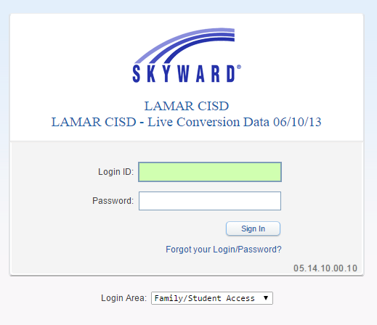
Check to make sure that you are accessing the Lamar CISD version of Skyward.
Make sure that you are in the Family/Student Access area. If not, use the drop down arrow to change it.
Type in your username (login ID) and password.
Click on “sign in” or press the “enter” key.
Signing Endorsements, Checking Grades, Attendance, Etc.
To sign endorsements, select the student that you are trying to sign endorsements for. If you only have one student, you do not have to do this- the system automatically defaults to your student. If you have more than one student, use the drop arrow in the upper left-hand corner next to “All Students” to select the student that you are signing for.

Click on “endorsements” in the left-hand menu.
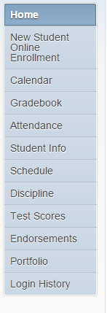
Click on “sign”.
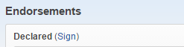

A box will open. Click in the square next to the words, “I agree”.
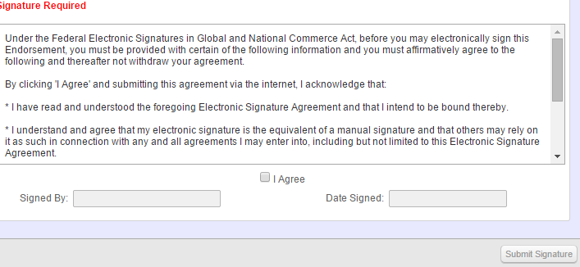
Your name will appear next to “Signed By” and the date will appear next to “Date Signed”.
Click “Submit Signature”.
You will see a message pop-up telling you that the signature was submitted successfully.

You can check your child’s grades, attendance, discipline and more, by choosing the option that you prefer from the menu on the left side of the screen.

When you have finished your session, always click on “exit” in the upper right-hand corner of the screen before closing the window.
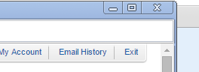

It is strongly discouraged that you share your username (login ID) and password with anyone- including your student. Your login information allows you to have access to all of your student’s academic records (which are highly confidential) and allows you to sign certain documents pertaining to your child electronically. For these reasons, it is strongly encouraged that you keep your login information as private as possible.

