February 15, 2022

CONSIDER APPROVAL OF ATTENDANCE BOUNDARY

FOR PHELAN ELEMENTARY SCHOOL

RECOMMENDATION:
After consideration of information from the district demographer (PASA), Administration and feedback from the community immediately impacted by zoning decisions related to the opening of Phelan Elementary, we recommend that the Board of Trustees approves Zoning Option 3.

IMPACT/RATIONALE:
With Phelan Elementary opening in August 2022, Lamar CISD needs to rezone in order to create the population of students who will attend this campus.

The goal of rezoning is to more evenly distribute enrollment across our elementary schools. Currently, approximately one-third of Lamar CISD’s elementary schools are over capacity. Several schools, however, are well under their enrollment caps.
By rezoning, students at all impacted schools can receive improved learning experiences. Rezoning to more evenly distribute our students across schools will relieve stretched resources and overcrowded classrooms in schools currently over enrollment and will increase per-capita funds and resources to schools currently under enrollment.

Administration shared current and projected enrollment information with members of the Phelan Elementary Attendance Boundary Committee which included representatives from the following school communities potentially impacted by the zoning decision:

Arredondo Elementary
Hutchison Elementary
Thomas Elementary
Williams Elementary

In addition, Administration distributed a survey to parents in these communities.

Submitted by: Sonya Cole-Hamilton, Chief Communications Officer
Kevin McKeever, interim Chief Operations Officer

Recommended for approval:
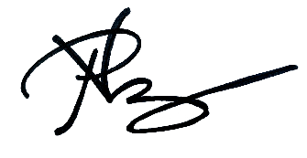
Dr. Roosevelt Nivens
Superintendent

